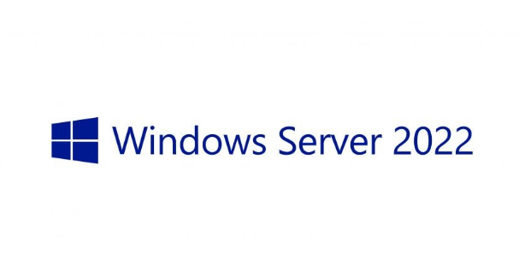
- First Install Windows Server Standard/Datacenter 2022/ 2025
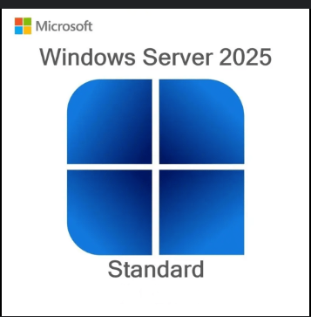

- After signing in to WIndows server 2022/2025 Start by opening “Server Manager” And Click on “Add Roles and Features”
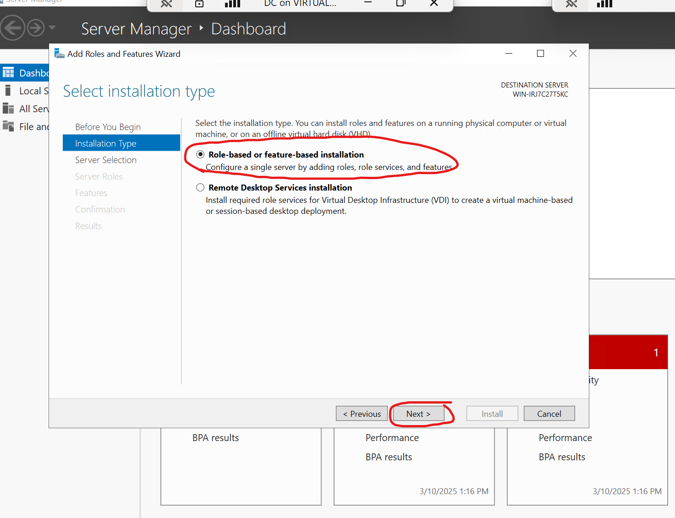
- Select the correct server for installing the Active Directory with “Active Directory Domain Services”
This will install the AD domain tools to assist using/repairing/uninstalling you Active Directory Service.
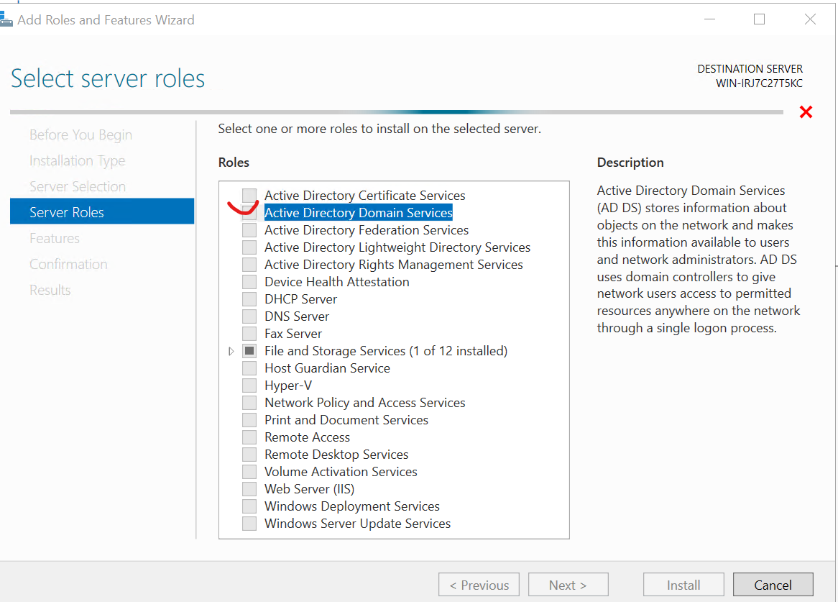

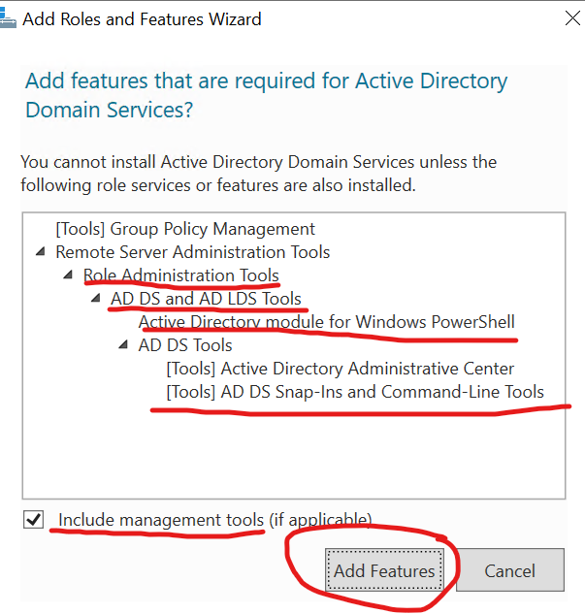
You may choose if Management tools is important to your organization or not.

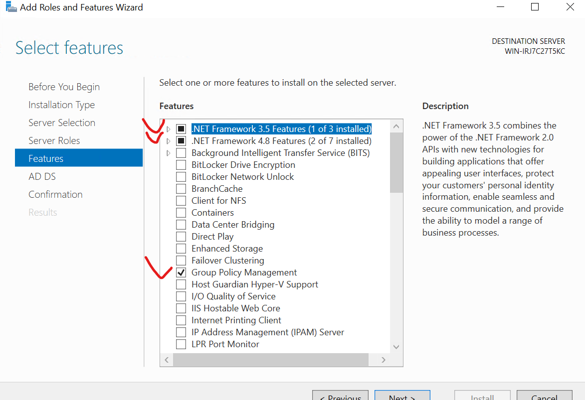
- Next check that “NET framework” will be installed alongside “Group Policy Management”

- Before confirming the installation Remember to Check your DNS Server was installed So your AD has something to connect to every other machine.
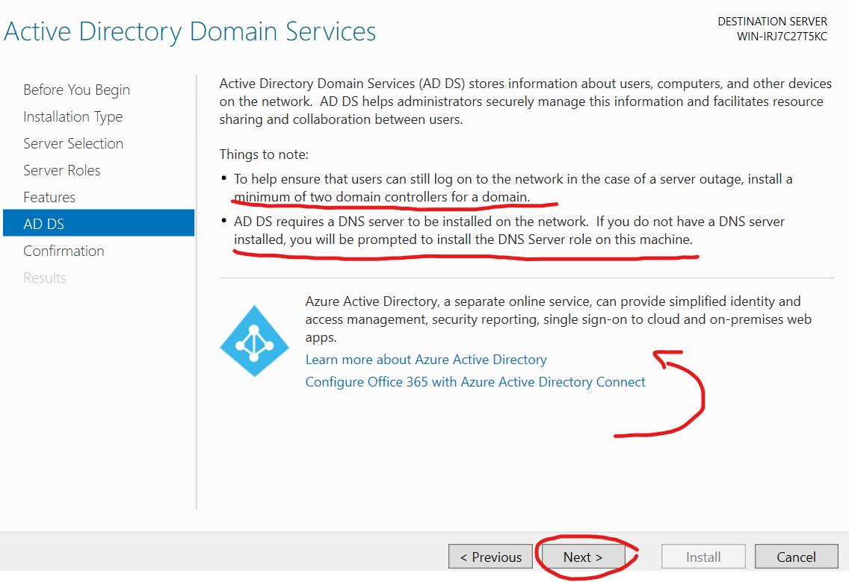
Now Install your AD and allow it to perform a Restart in the checkbox.
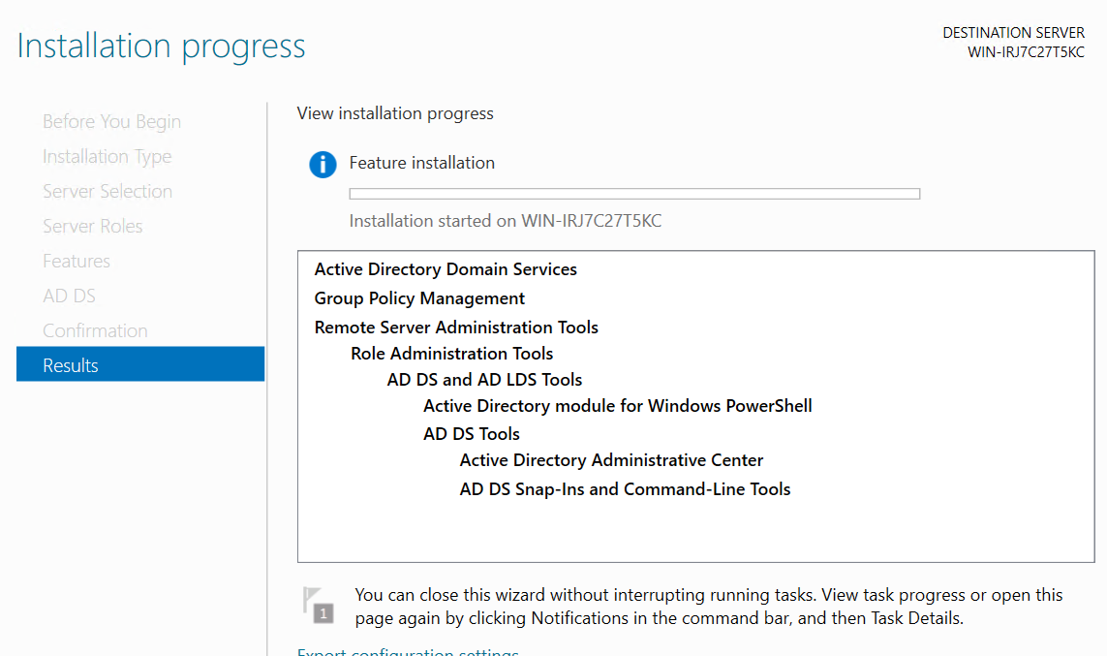

- Before restarting your Server you must promote the Server to a domain controller in the top -Right corner a flag with a appear for you to “promote the server to a Active Directory Domain”
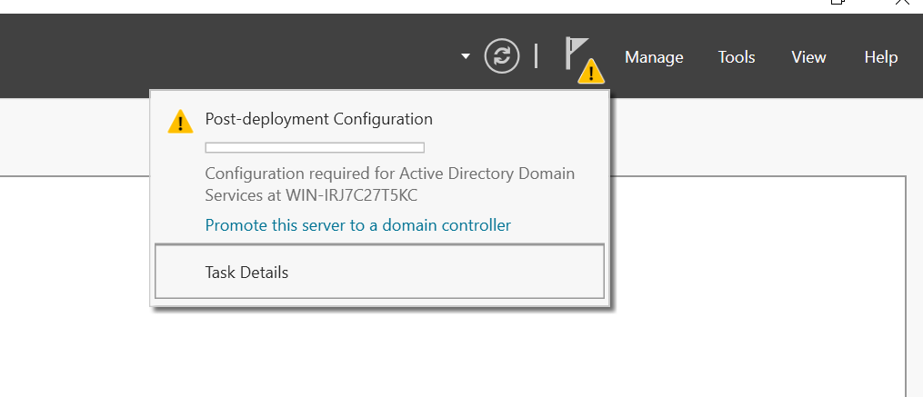

- Add your New Forest Domain with your Registered Domain for your company to use properly with regulation.
https://learn.microsoft.com/en-us/troubleshoot/windows-server/active-directory/naming-conventions-for-computer-domain-site-ou

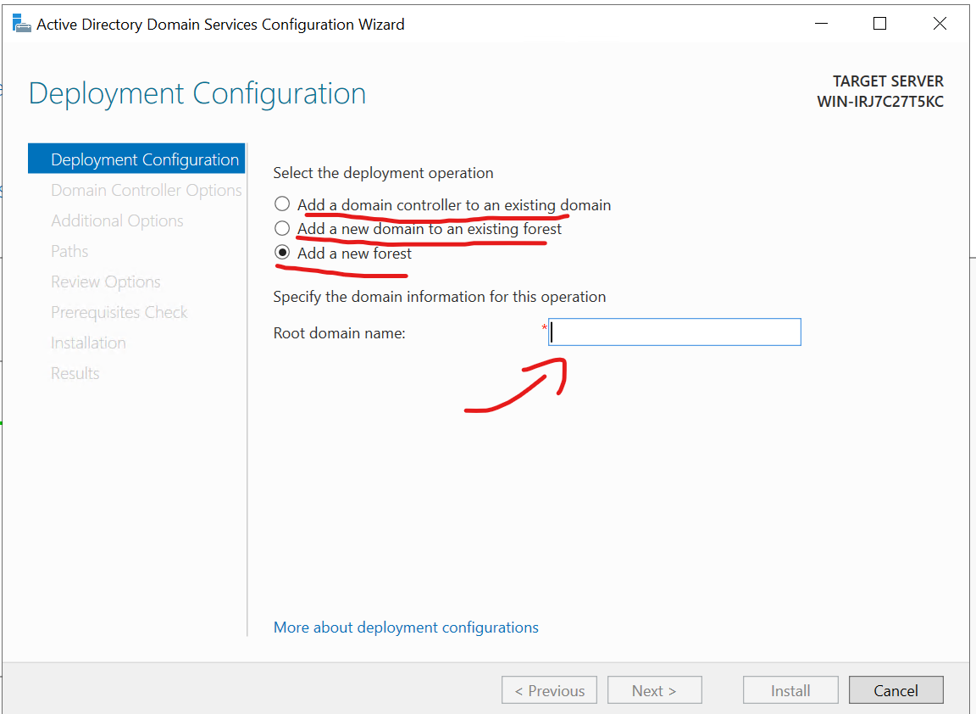
- Add a solid password in case you need to use the Restore mode for failing AD
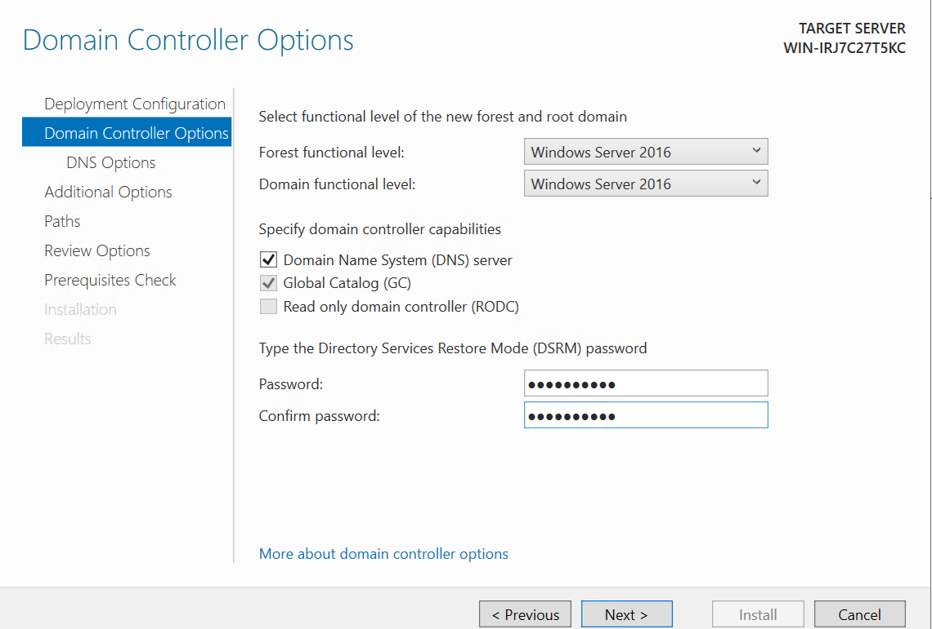

- DNS Delegation is only Necessary if your adding on to another DNS environment.

NETBIOS will provide the name you first gave to the server
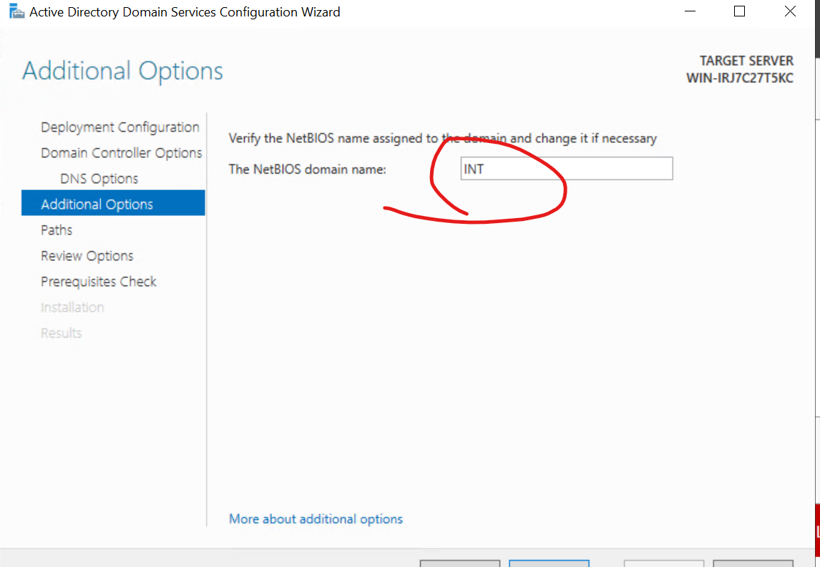

Make sure it goes to the correct name space
